Project # 2 EE596

Title: Design of S/H Circuit

Mohammad Chahardori

ID:11632753

Date: 05/01/2019

- Differential Signaling:
In fig.1 the circuit and the sizing of transistors and capacitors for differential T/H are shown.

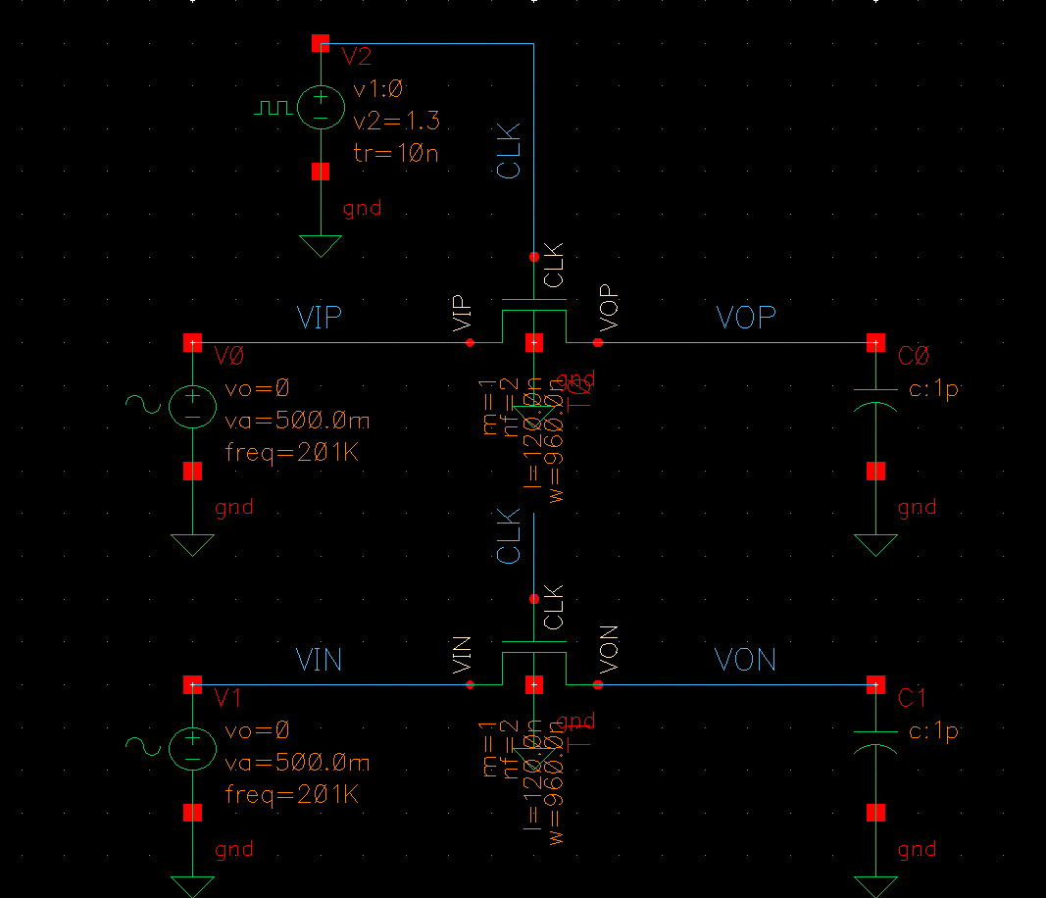
Fig.1. Schematic and device sizing of differential T/H

As shown in fig.1 the amplitude of the input signal is 1V differential and the frequency is 201KHz. The CLK signal has 1.3V amplitude and 100ns period (FCLK=10MHz). In fig.2 the input and output signal along with CLK signal have been shown. Fig.2 shows that the tracking and holding are being done with negligible loss in signal amplitude.

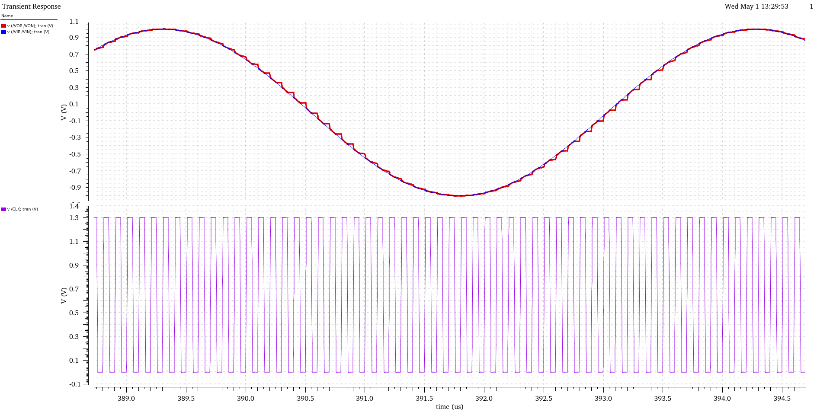
Fig.2. Input, Output and CLK signals
In fig.3 the spectrum of the output differential signal has been shown. Because of the differential signaling we don’t see second harmonic. The third harmonic is the largest harmonic. According to fig.3 the SFDR is 54.76dB when (1V) 0dB input signal has been applied to the T/H input.

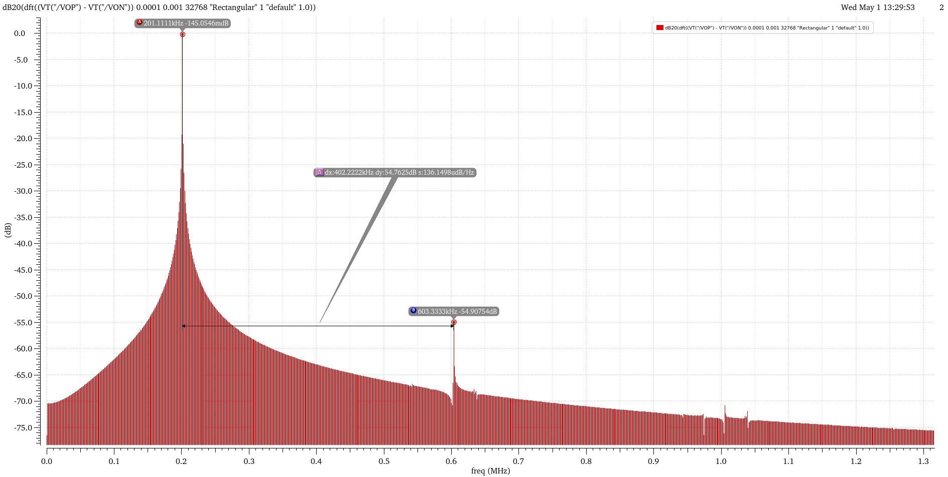
Fig.3. spectrum of the output differential signal

To realize the improvement in SFDR of the T/H circuit due to employing differential structure, I have simulated the single ended T/H with same specification and its spectrum is seen in fig.4. The SFDR of the single ended input is 46.3dB which is due to 2nd harmonic. That means, using differential signaling not only has been doubled the swing of the output but also it has improved the SFDR by 9dB.
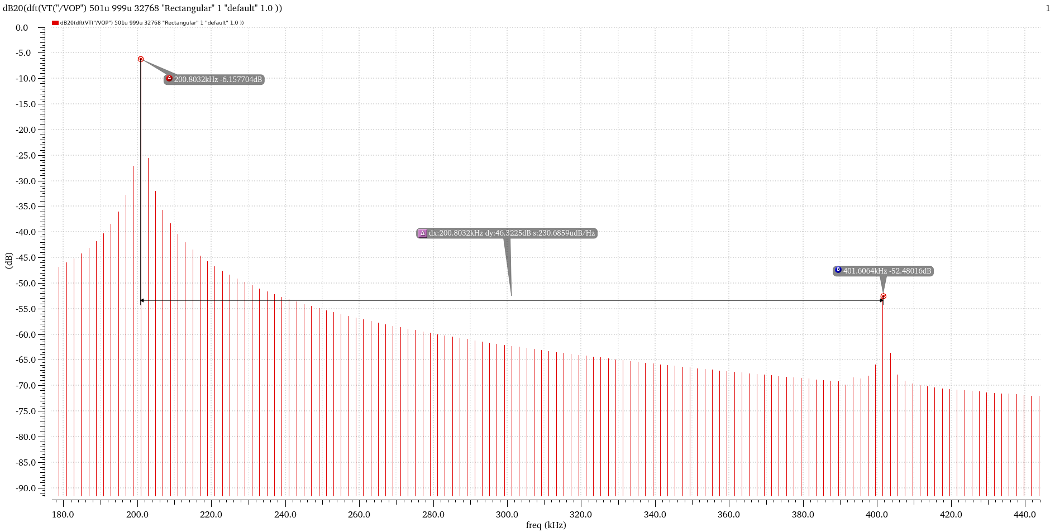
Fig.4. spectrum of the output single-ended signal

- Bottom-Plate Sampling:
In fig.5 the circuit and the sizing of transistors and capacitors for bottom-plate T/H are shown.

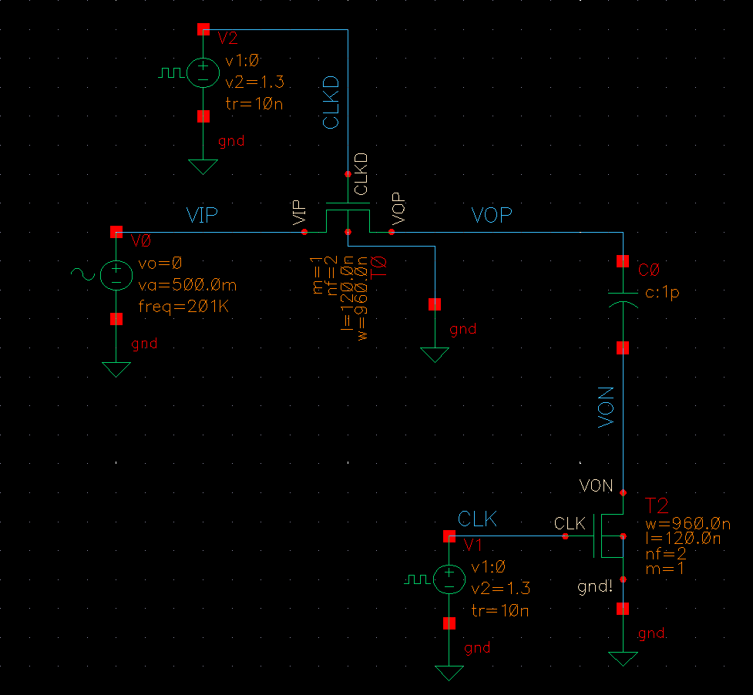
Fig.5. Schematic and device sizing of Bottom-Plate T/H

As shown in fig.5 the amplitude of the input signal is 0.5V and the frequency is 201KHz. The CLK signal has 1.3V amplitude and 100ns period (FCLK=10MHz). In fig.6 the input and output signal along with CLK signal have been shown. To see the T/H signal much clearer in fig.7 and fig.8 the input/output signals and CLK and CLKD have been shown separately. Fig.7 shows that the tracking and holding are being done with negligible loss in signal amplitude. In fig.8 we can see that the delay between CLK and CLKD signal is about 10ns which is about 10 percent of the CLK period. This delay value selected to optimize the SFDR.
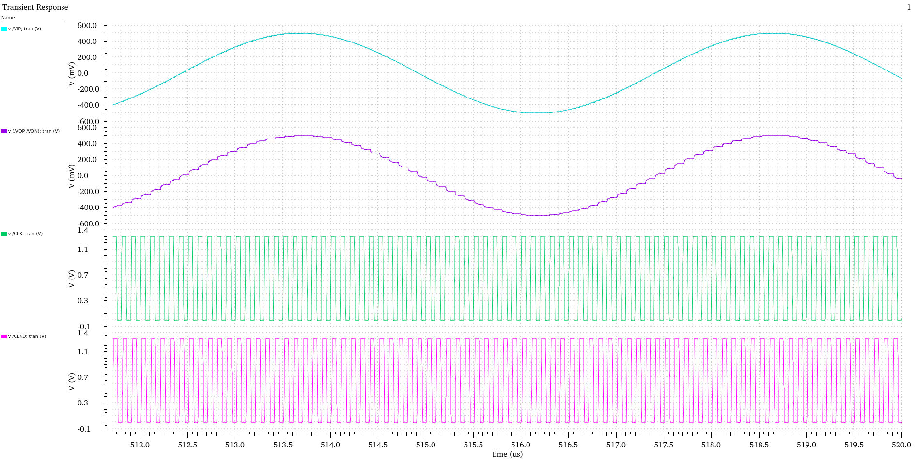
Fig.6. Input and output signal along with CLK signal in Bottom-Plate sampling

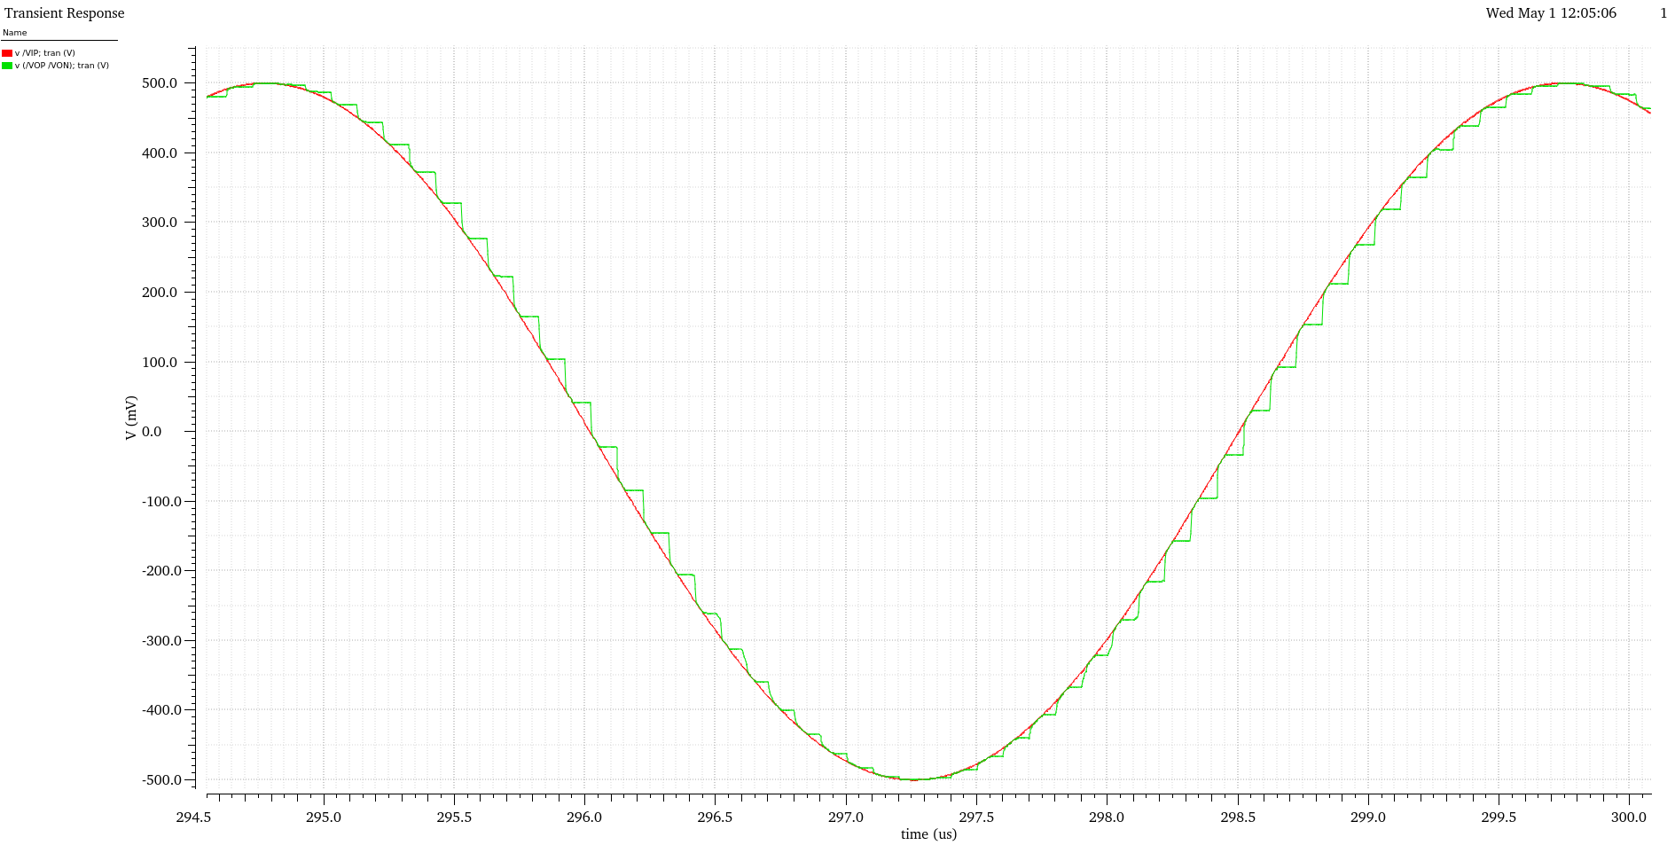
Fig.7. Input and output signals in Bottom-Plate sampling

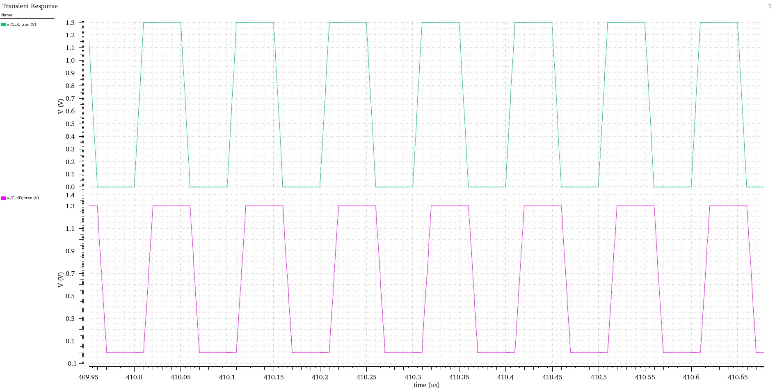
Fig.8. CLK and CLKD signals in Bottom-Plate sampling

In fig.9 the spectrum of the output bottom-plate sampled signal has been shown. Because of the bottom-plate sampling the SFDR is 55.08dB when (0.5V) -6dB input signal has been applied to the T/H input.

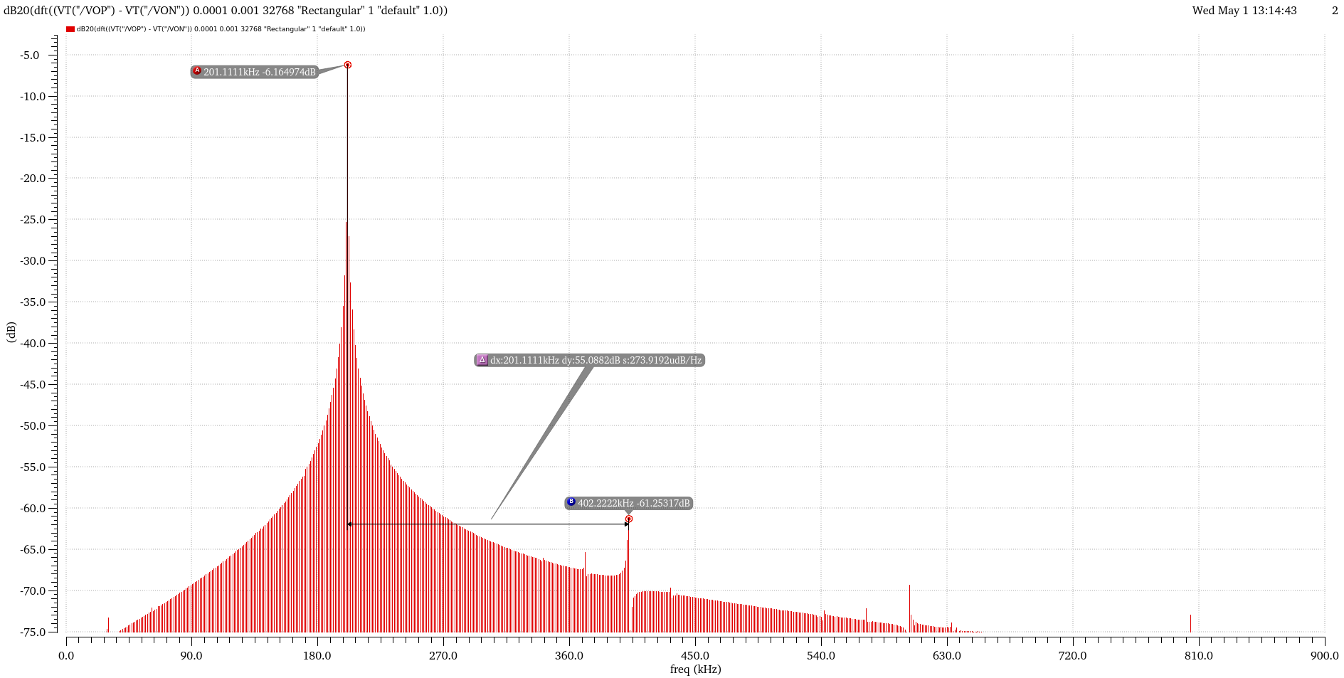
Fig.9. spectrum of the output bottom-plate sampled signal

- Bootstrapping with Bottom-plate sampling (together)

Unfortunately, I did not have enough time to finish this part, so I add one of my previous designs of T/H with bootstrapping which has been done in 0.18um TCMS technology. The target of this T/H was achieving high SFDR at 200MS/s CLK signal with 1V input signal for a pipeline ADC. In fig.10 the final structure of the T/H circuit has been shown.

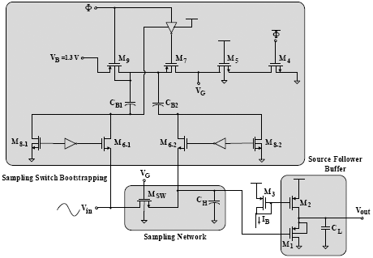
Fig.10. Structure of the T/H circuit

The main idea in fig.10 is the usage of two identical clock bootstrapping circuit for DG and SG of the sampling transistor to improve the linearity when Vin(n)>Vin(n-1) and also when Vin(n)<Vin(n-1) which has been published by M. Waltari et al (ISSCC 2002). In this figure also some other modifications like connecting bulk of M9 to the top plate of CB1 instead of VDD has been done by us which improves the SFDR to some extent which has been published in (IEEE SMACD Conference 2018). The sizes of the transistors in this structure are as follow:

Size(µm/µm) | Device | Size(µm/µm) | Device
52.5/0.46 |  | 31.5/0.18
17.5/0.18 |  | 630/0.46
8.75/0.18 |  | 420/0.46

In fig.11 the output signal when Fs=200MS/s and Fin= 1MHz and 99.4 MHz have been shown. In fig.12 the
Output spectrum when Fs=200MS/s and Fin= 30MHz and 99.4 MHz have been shown. As depicted in fig.12 with 1V input signal amplitude the achieved SFDR is better than 77.6dB close to 13-bit in both input frequencies.

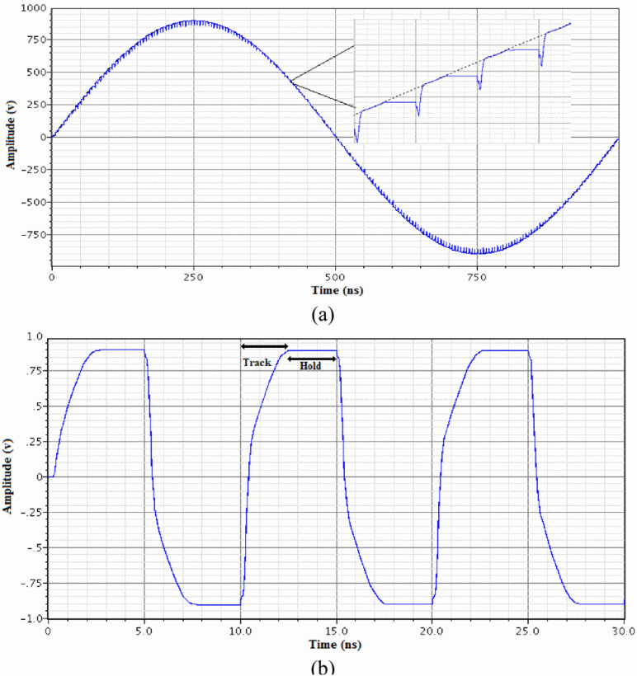
Fig.11.Output signals of T/H when Fs=200MS/s and Fin=1MHz and 99.4MHz are applied as input

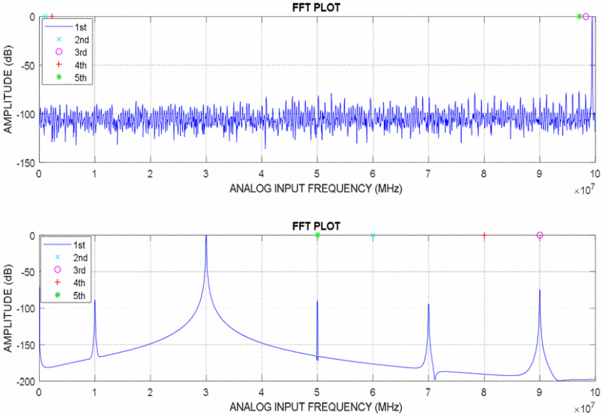
Fig.11.Output spectrum of T/H when Fs=200MS/s and Fin=30MHz and 99MHz are applied as input

